**Information about the Activity**

* **Title of the Workshop**: 7 days Text-Reading International E-Workshop on "Tarkamritam"
* **Type of the Activity**: International E-Workshop
* **Organizing Department**: Department of Sanskrit, Chakdaha College and Department of Sanskrit, Bagula College
* **Date and time of the Activity**: 21.09.2020 - 27.09.2020, 01:00 P.M to 02:00 P.M Every day.
* **Number of participants**: 1234
* **Speakers**:
  + Prof. (Dr.) Bishnupada Mahapatra, Department of Nyaya, Shri Lal Bahadur Shastri National Sanskrit University, Delhi;
  + Dr. G. Jayamanikya Shastri, Associate Professor, S.J.S.V., Puri
* 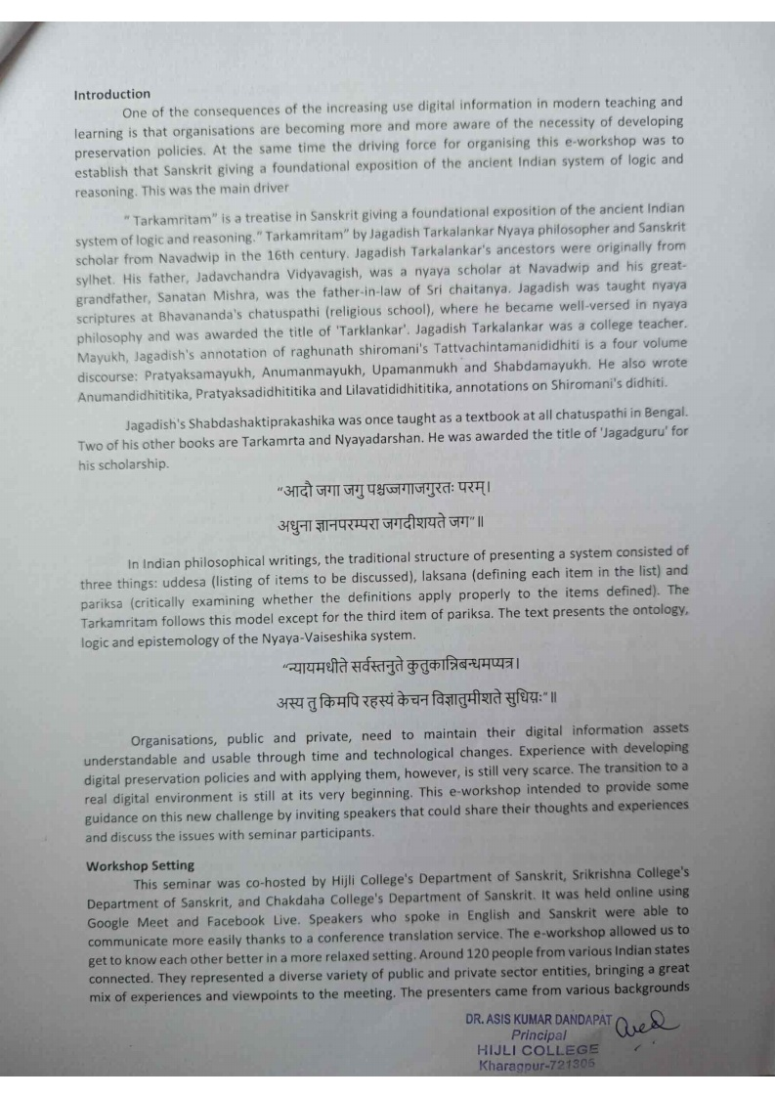**Information about Seminar:**

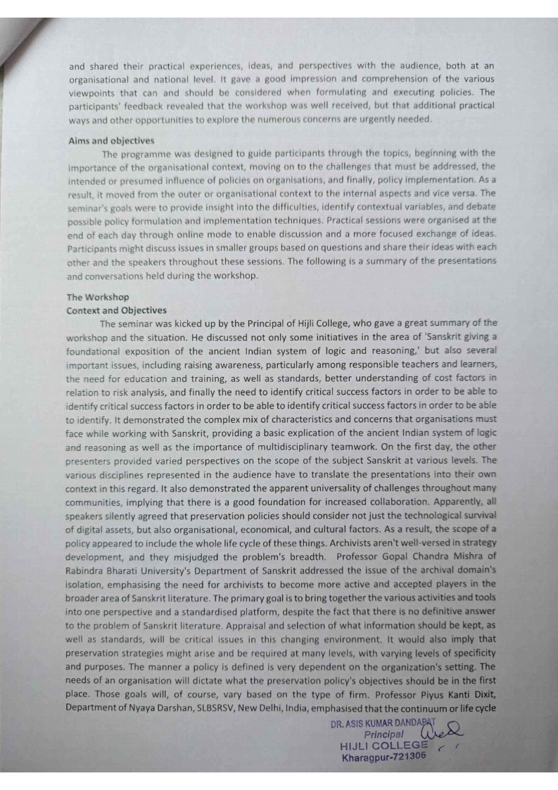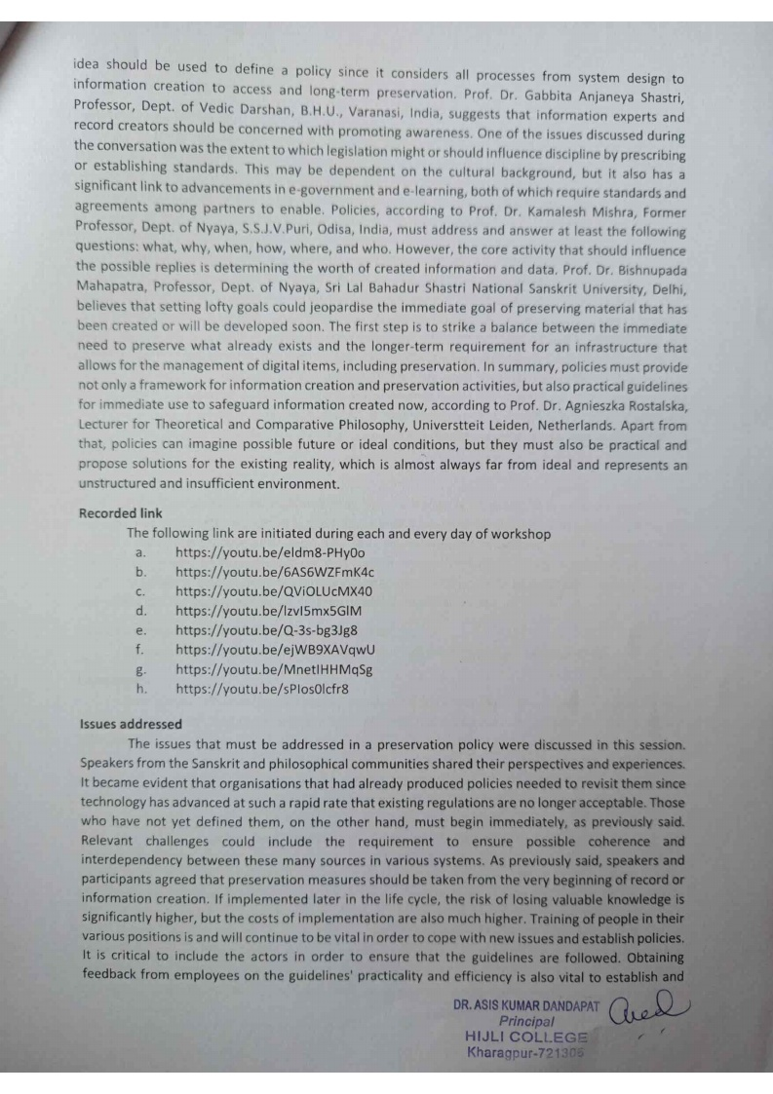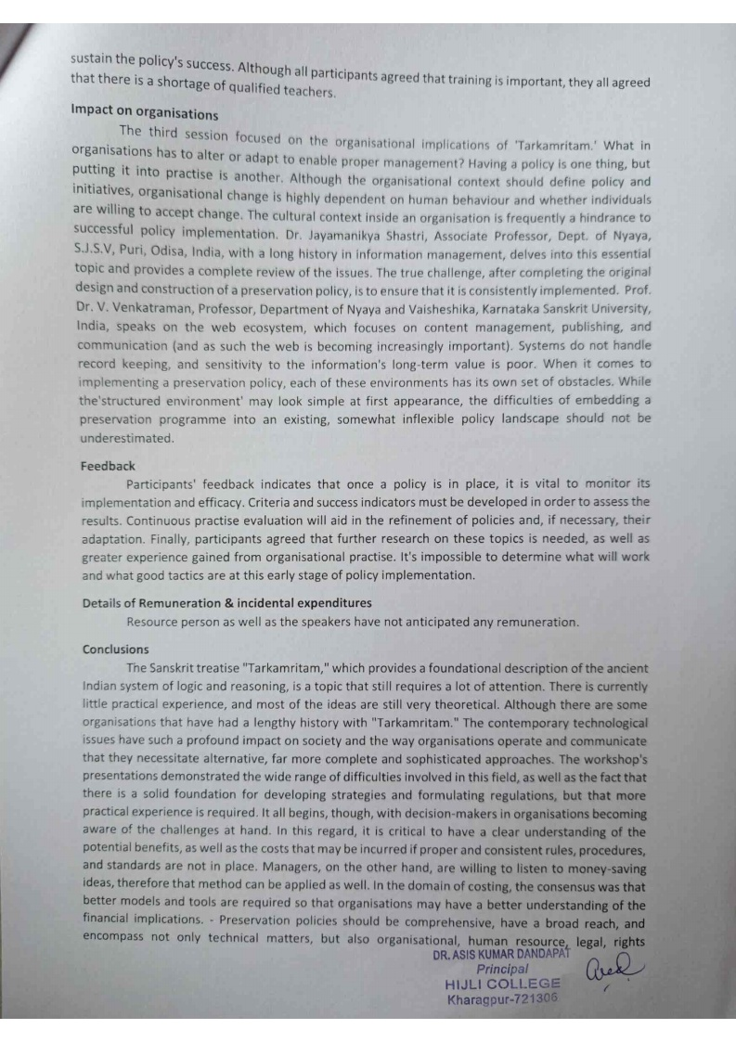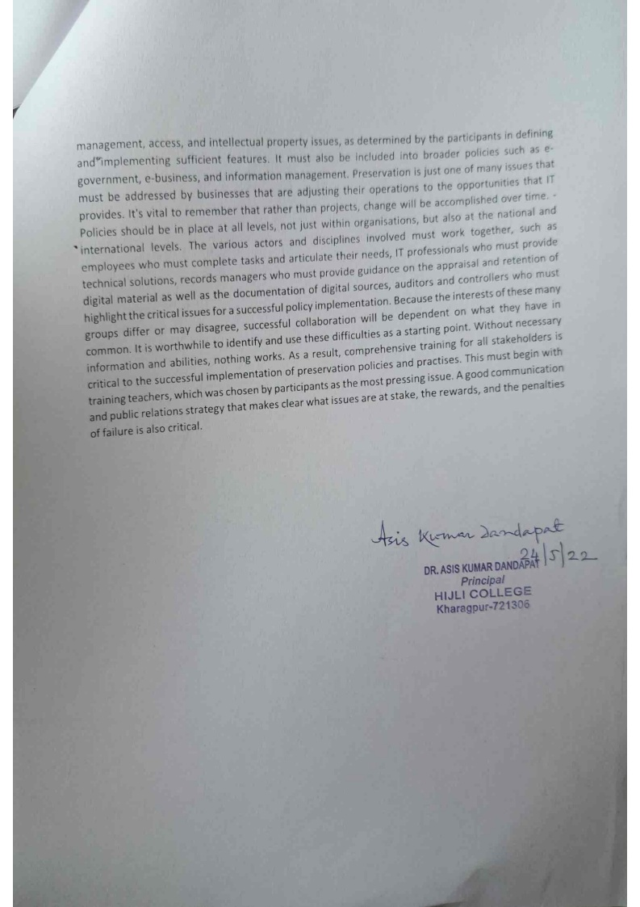

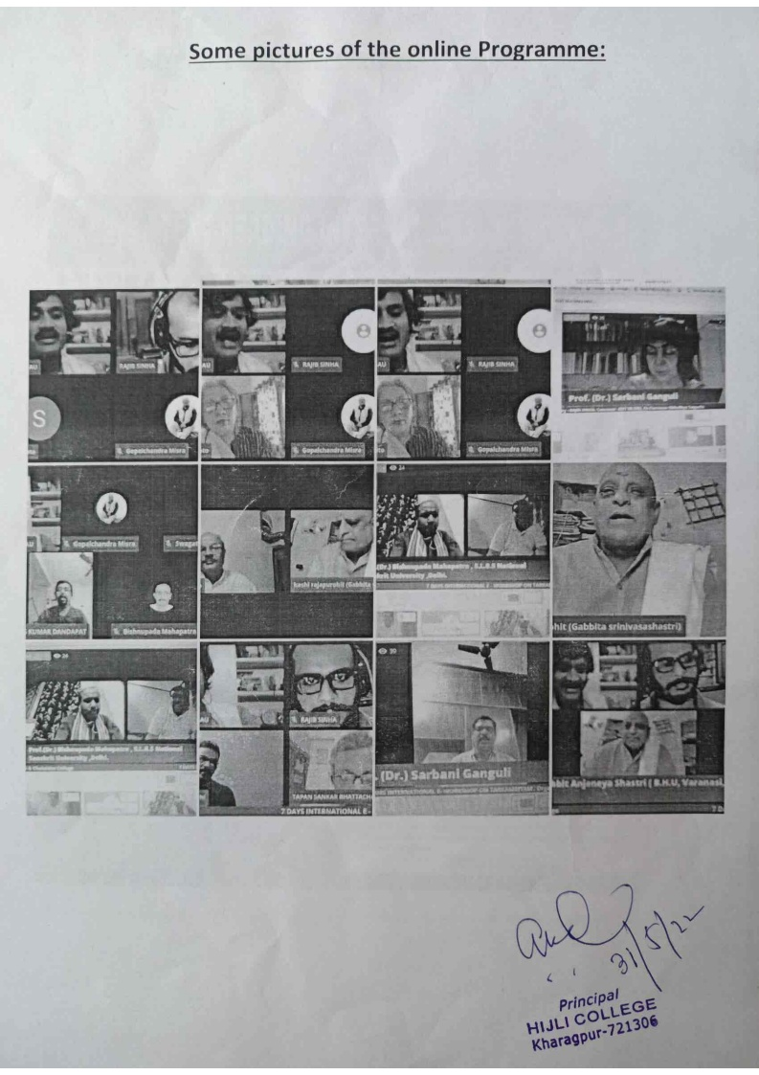

***Relevant Web Link:***

<https://youtu.be/6AS6WZFmK4c>

<https://youtu.be/QViOLUcMX40>

<https://youtu.be/lzvI5mx5GlM>

<https://youtu.be/Q-3s-bg3Jg8>

<https://youtu.be/ejWB9XAVqwU>

<https://youtu.be/MnetIHHMqSg>